Current AVF system is running on **MS SQL Database** and we will migrate into **MYSQL Database**

Followings objects will be migrated into MYSQL

1. Table
2. Procedure
3. View
4. Functions
5. Existing Data

Other database objects will not be migrated.

We prefer Amazon SCT and DMS to migrate those objects.

Step 1: **SCT (Schema Conversion Tool**): SCT will be used to convert schema from source to destination database.

This step is required because Schema is Different in Different database

Step 2: **DMS (Database Migration Service**): after migration of Schema, DMS service will be use to port data from

Source to migration database.

**Approach 1**

**In this approach, network connectivity is established between AWS DMS and SCT to In-House MS SQL Database.**

**This is recommended approach. And Downtime will be lesser.**

1. Create Network connectivity from Existing In-House Database to AWS Environment
2. Use AWS DMS (Database Migration Service) to connect to In-House MS SQL Database as Source
3. Use Migration Task to migrate data

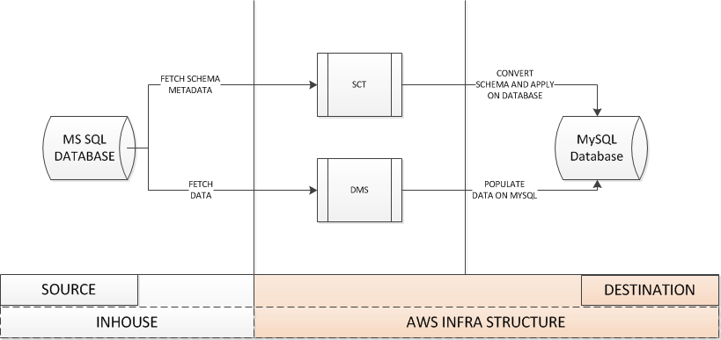

Approach 2

**In this approach, Database dump is taken from In-House Source database and populate an intermediate / staging database within AWS region. And Then Database Migration took place from staging database to destination database.**

**Much higher Downtime (Around 24 Hours) is required.**

Take Database Dump from Existing Database (In-house Database)

1. Take Dump into MSSQL Staging Database
2. Use AWS DMS (Database Migration Service) to connect to STAGING MS SQL Database as Source
3. Use Migration Task to migrate data

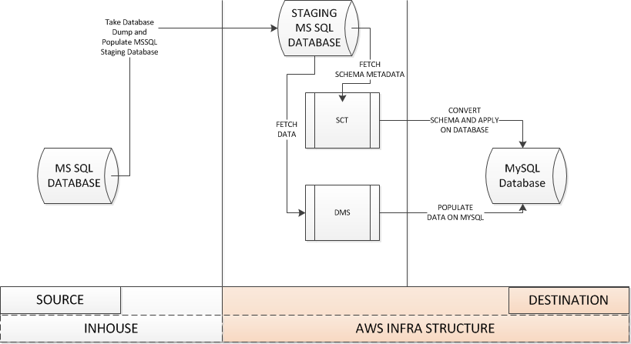

I will prefer for Approach 1, As expected Downtime for Approach 1 will be less. (At this point I am not in a position to tell how less, because we need to run one round of exercise of that Approach, But in this process we should be able to migrate Delta amount of changes, We will migrate Maximum static tables outside migration time and during migration we can migrate transactional tables only)

For Approach 2 we may need considerable high System Downtime. If we get Downtime around 24 Hours

Then this can be executed

Comparison

|  |  |
| --- | --- |
| Approach 1 | Approach 2 |
| This approach need direct network connectivity between Atos Network and AWS Network | This do not require network connectivity between Atos and AWS |
| This will require lesser system down time | This will require much higher system down time |
|  |  |